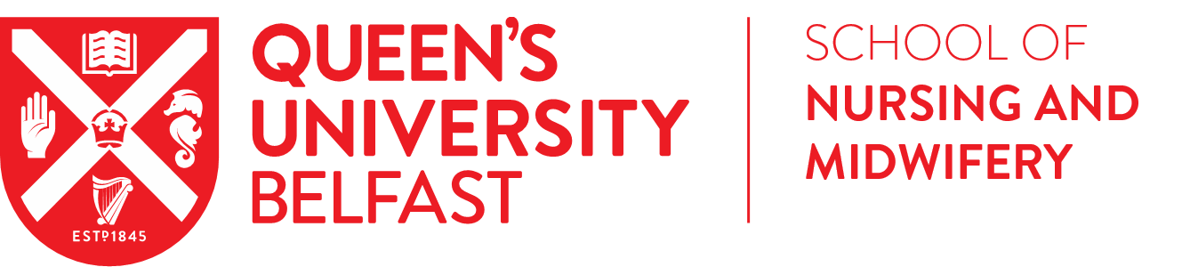

RESEARCH STUDENTSHIP SCHEME
Student Guidance & Application Form
Overview
A key area of the School’s SWAN Action plan is the promotion of an academic career to students. To address this, we are pleased to announce the launch of the 2025/26 Research Studentship Scheme open to undergraduate students scheduled to graduate this academic year and postgraduate taught (MSc) students to undertake research activities in the School of Nursing and Midwifery. There are four studentship awards available for £1,200 each, providing a stipend of £200 per week for six weeks working on a full-time basis or £100 per week for 12 weeks working on a part-time basis.

Obtaining the studentship will be a competitive process. The Scheme is open to students:
- Scheduled to graduate from an undergraduate degree programme in December 2025/July 2026 or enrolled on a postgraduate taught programme (MSc) in the School of Nursing and Midwifery, Queen’s University Belfast
- Able to work in the UK i.e. NI/GB/ROI students or EU (non-Irish)/International students with a work permit or settled/pre-settled status
- Available to take up the studentship in accordance with their degree pathway i.e. following completion of all taught elements.

Successful students will work alongside the supervisor(s) to complete the studentship on a full-time basis (30 hours per week) over six consecutive or non-consecutive weeks. We will also consider part time appointments e.g. completion of the studentship on a part-time basis (15 hours per week) over 12 consecutive or non-consecutive weeks. Students will be awarded a stipend of £200 per week (or pro-rata on a part-time basis).

Student Application Process
Interested students are asked to complete the student application form, overleaf, and submit alongside a short one-page CV and a copy of their unofficial academic transcript from their current degree programme.
The short one-page CV must provide details under the following headings:
- Academic achievement
- Work experience
- Research experience/interests

An unofficial copy of a student’s academic transcript can be accessed via Qsis > Self Service > Student Centre.

Student applications will be reviewed at School level by a selection panel nominated by the Head of School comprising of the Head of School, Director of Research and Director of Education, or their nominees. Applicants will be assessed on their:
- Academic profile
- Level of experience
- Fit of research interests to the studentships on offer

The deadline for applications is Monday 29 September 2025 at 5pm
Applications must be submitted via email to Dr Fiona Lynn (f.lynn@qub.ac.uk)

Students will be notified of the outcome by 10 October 2025

If you have any queries about the application process or the studentships on offer, please contact Dr Fiona Lynn (f.lynn@qub.ac.uk) or the relevant lead supervisor for the studentship. An information session will be held on Monday 22 September at 1.30pm via MS Teams, where students can hear about the scheme and ask questions.
___________________________________________________________________________
Microsoft Teams Need help?
Join the meeting now
Meeting ID: 370 382 605 172 5
Passcode: e7Uh798e

Dial in by phone
+44 20 4534 2864,,543670338# United Kingdom, City of London
Find a local number
Phone conference ID: 543 670 338#
For organisers: Meeting options | Reset dial-in PIN
________________________________________________________________________________

STUDENT APPLICATION FORM
Name of student: | Student number:
Programme and year of study:
Registration
☐ NI/GB/ROI student ☐ EU (non-Irish)/International student
If you are registered as an EU (non-Irish)/international student, do you have a work permit or settled/pre-settled status for the UK?
☐ Yes ☐ No
Research studentship
Please indicate which research studentship(s) is/are of interest to you:
☐ Evaluation of an educational intervention to engage registered nurses in Palliative and end of life caRe simulAtion for people with end-stage kIdney diseaSE: the PRAISE study
☐ Exploring Interdisciplinary Students Perspectives through Focus Groups on the Co-Design of an Anatomy Serious Game
☐ An exploration of cognitive impairment in children with cerebral palsy
☐ Strengthening Bioscience in Nurse Education: Surveying Current Practice and Building Shared Assessment Resources

Proposed start date and duration
If successful, when would you be able to commence the studentship?
Date: ____ / ____ / ____
If successful, would you prefer to take up the studentship on a full-time (6 weeks) or part-time (12 weeks) basis?
☐ Full-time ☐ Part-time

Please email this completed application form, along with a short one-page CV and academic transcript to Dr Fiona Lynn (f.lynn@qub.ac.uk). The deadline for applications is 29 September 2025 at 5pm.
Checklist
☐ Student Application Form
☐ Short one-page CV
☐ Academic Transcript

